Twitter Clone

The main purpose of the app is to give users a convenient way to connect and share with others.

Technologies

**Front end** – Flutter

**Backend** – Nodejs and Express

**DB** – Mongo DB



The user can see other people posts and interact with them by liking and commenting.

Also, the user can upload a post by himself.

***Main Pages***

**\*All the mockups shown are not the finale design**

Home Page

Presents the latest Posts uploaded by the users friends that he follows.   
At the top presented a header with the twitter logo. Then all the posts will be shown in a scrollable component, so that the more the user scroll, the older the posts the user see.

**Data to fetch** - List of posts according to the users that the logged user is following, sorted by date and time.

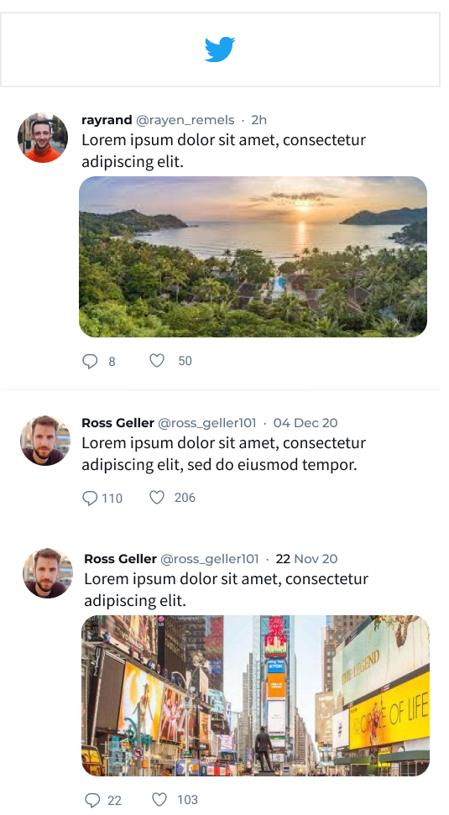

User Page

Presents the user details including he's profile-picture, header, user-name, name and biography (optional).

A button to follow/unfollow the user (wont show if the user is in he's own profile page).

At the rest of the page there is all of the user's posts in a chronological order.

**Data to fetch** – the user details along with all his post sorted by date and time.

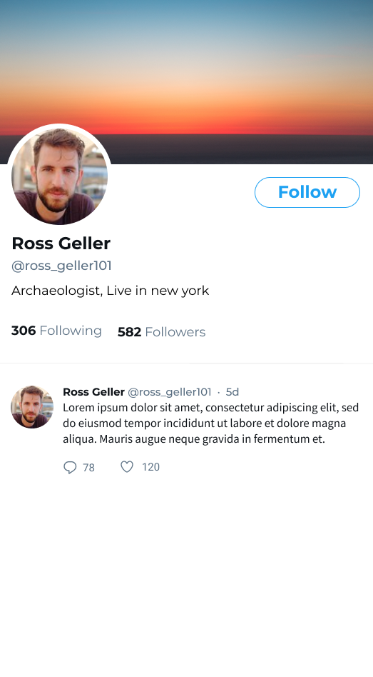

*Main Components*

*Post component*

Displays a single post content of a user. Contains an image, video, or just text. The user user-name will appear at the top of the post along with he's user-image. At the bottom of post, there is an action bar that lets the users choose to like and comment the post.

***Main Objects - FrontEnd***

User:

* UserID (Integer)
* Password (String)
* Name (String)
* Handle (String)
* Email (String)
* Bio (String)
* Photo (String)
* HeaderPhoto (String)
* Followers (List<Integer> user id's)
* Posts (List<Integer> post id's)
* Following (List<Integer> user id's)
* JoinDate ( String )
* FollowersCount (Integer)
* FollowingCounbt (Integer)

Post:

* PostID (Integer)
* UserID (Integer)
* Content
* Likes (List<Integer> user id's)
* Comments (List<Comments>)
* UploadTime (String)

Comment:

* CommentID (Integer)
* UserID (Integer)
* Body (String)
* UploadTime

**Navigation & Routs**

Each page in the app have a unique route to identify itself along with parameters (like /users/_id).

The Navigation mechanism, like most apps, is represented by a stack. The page at the top of the stack is the one represented on the screen, and all the others are "behind" it sorted till the page at the bottom of the stack. the most basic functions for navigations are that a page can be pushed (push) to the stack and removed (pop) from it.

From main screen To profile screen -> Push

From profile screen To main screen -> Pop

From main screen To logIn screen -> replace

From login screen To main screen -> replace

*API Endpoints*

In order to fetch data, we use the static functions in the api file.

Like:

Dislike:

Authenticate:

fetchProfilePageWallPosts:

fetchHomeWallPosts:

fetchUser:

userImageById:

userHandleById:

userNameById:

userFollowersById:

userFollowingById: